***CONTENTS***

* [**Scrum Roles**](https://assist-software.net/blog/scrum-framework-roles-activities-and-artifacts#scrum-roles)
  + [Product Owner](https://assist-software.net/blog/scrum-framework-roles-activities-and-artifacts#product-owner)
  + [ScrumMaster](https://assist-software.net/blog/scrum-framework-roles-activities-and-artifacts#scrummaster)
  + [Development Team](https://assist-software.net/blog/scrum-framework-roles-activities-and-artifacts#development-team)
* [**Scrum Activities**](https://assist-software.net/blog/scrum-framework-roles-activities-and-artifacts#scrum-activities-and-artifacts)
  + [Sprint Planning](https://assist-software.net/blog/scrum-framework-roles-activities-and-artifacts#sprint-planning)
  + [Daily Scrum](https://assist-software.net/blog/scrum-framework-roles-activities-and-artifacts#daily-scrum)
  + [Sprint Review](https://assist-software.net/blog/scrum-framework-roles-activities-and-artifacts#sprint-review)
  + [Sprint Retrospective](https://assist-software.net/blog/scrum-framework-roles-activities-and-artifacts#sprint-retrospective)
* **Time Duration**
* Sprints
* Sprint goals
* Sprint backlog
* Product backlog

**Scrum Roles**

Scrum team are made up of three important roles: Product owner, Scrum Master, Development Team.

**PRODUCT OWNER**

* is the empowered central point of product leadership
* is the only authority responsible for what will be developed.
* Maintains and communicates to all other participants a clear vision of what the Scrum team is trying to achieve
* the product owner is responsible for the overall success of the solution being developed or maintained.

**SCRUM MASTER**

* helps everyone involved understand and embrace the Scrum values, principles, and practices
* acts as a coach, providing development process leadership
* as a facilitator, ScrumMaster helps the team resolve issues and make improvements to its use of Scrum
* is responsible for protecting the team from outside interference
* takes a leadership role in removing impediments that inhibit team productivity
* has no authority to exert control over the team, so this role is not the same as the traditional role of project manager or development manager. The Scrum-Master functions as a leader, not a manager.

**DEVELOPMENT TEAM**

* the development team self-organizes to determine the best way to accomplish the goal set out by the product owner
* is typically five to nine people in size; its members must collectively have all skills needed to produce good quality, working software.

**ACTIVITIES**

**Sprint Planning:**

This is 2 hours per week time-boxed meeting where the team determine the most important subset of product backlog items to build in the next sprint, the product owner, development team, and ScrumMaster perform **sprint planning**.

**Daily Scrum:**

This is 15 mins time- boxed meeting where the development team will provide updates on their progress and plans for next 24 hours, ensuring all team members are aligned and any blockers are addressed

**DONE**

In Scrum, we refer to the sprint results as a potentially shippable product increment, meaning that whatever the Scrum team agreed to do is really done according to its agreed-upon definition of done.

**Sprint Review:**

This is 2 hours time boxed meeting where the development team showcases what they delivered during the sprints and collects feedback from stakeholders.

**Sprint Retrospective:**

This is 1 hour time boxed meeting where the development team and scrum master reflect on the sprint and identify areas of improvement, with a focus on increasing efficiency and effectiveness in the serving customers.

**Backlog Refinement:**

This is an ongoing activity where the product owner and development team maintain and refine the product backlog , ensuring it aligns with evolving needs of the project.

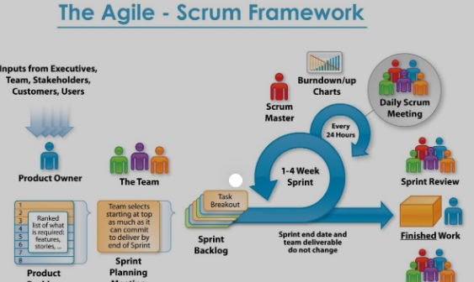

**Time Duration**

**Sprints:**

A sprint is a short, time-boxed period, usually ranging from one to four weeks, in which a team works to complete a set of goals and deliver a usable product increment.

The time duration of a sprint is agreed upon by the development team and stakeholders at the start of a project, and it is typically kept consistent throughout the project.

**Sprint Goal:**

a short, clear statement that defines what the team is trying to achieve during the sprint.

**Sprint Backlog:**

the set of items that the team plans to complete during the sprint.

**Product Backlog:**

a prioritized list of items that represents the work that needs to be done to deliver value to the customer.

***NOTE:***

The time boxed activities are strict and should not exceed the designated time limit, while the time duration of the sprint can be adjusted based on needs of the development team and products backlog with a focus on delivering the best possible experience for the customers.